DC Motor Control Analyze and Improvement
1: DC Motor Rotation CW: (high slide on) 1
2: DC Motor Rotation CCW: (low slide on) 2
3: Signal description: 2
4: Motor FB Function description: 3
5: New Proposal about the DC motor driving 4
5.1: Existing DC motor driving analyze 4
5.2: The new architecture proposal: 5
5.2.1: Speed feedback module: 6
5.2.2: PWM Generator: 6
5.2.3: PWM update control state machine: 6
5.2.4: Implement order: 7
5.2.5: Question 7

1: DC Motor Rotation CW: (high slide on)

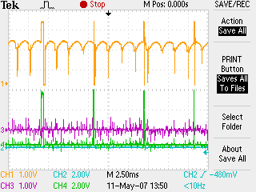

Figure 1.1: DC Motor Control Wave 1

2: DC Motor Rotation CCW: (low slide on)
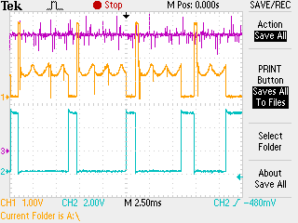

Figure 1.2: DC Motor Control Wave 2

3: Signal description:
Figure 1.1:
- CH1: WPMOT1_FB.
- CH2: WPMOT1_N.
- CH3: MOTCOM_P_PRE
- CH4: WPMOT1_P.
Figure 1.2:
- CH1: WPMOT1_FB.
- CH2: WPMOT1_N.
- CH3: MOTCOM_P_PRE

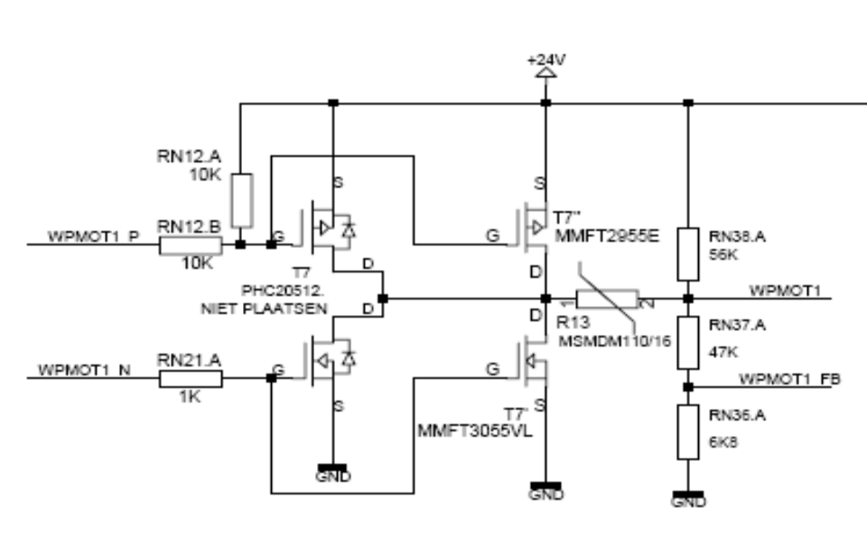
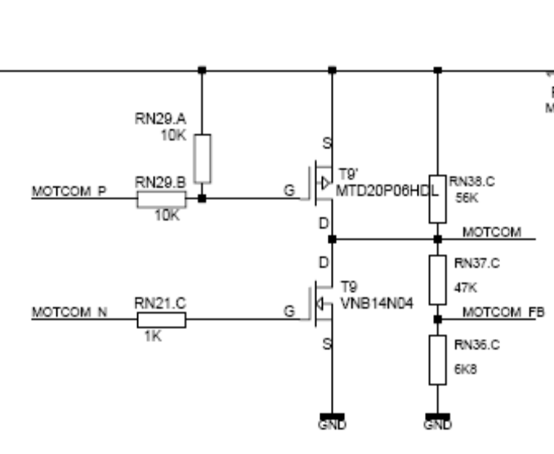

4: Motor FB Function description:
In SL general system hardware design, we can’t get the motor current directly; we only know the motor speed from the motor feedback signal. And the software program will sample this signal, and then update the PWM ration with PID algorithm. So that we can hold the motor speed on a stable value or a target value.
Did we need a circuit to detect the motor current? From software opinion, I think it isn’t necessary for our system.

5: Motor PWM Bridge Feedback and motor rotation speed calculation.
When the PWM bridge high slide is driven by PWM wave, the Motor Eg = 12V..0V, So the ADC range is about 1.5V..0V, corresponding the Motor speed is MaxSpeed..0,
When the PWM bridge low slide is driven by PWM wave, the motor Eg = 12V..0;
The sample point voltage is 12V..24V.And the ADC range is 1.5V..3V, and the corresponding motor speed is MaxSpeed ..0
In Motor control SW, we will sample the ADC voltage, and do a subtraction when
Low slide is on, and so we can get a diagram for ADC& Speed relation.

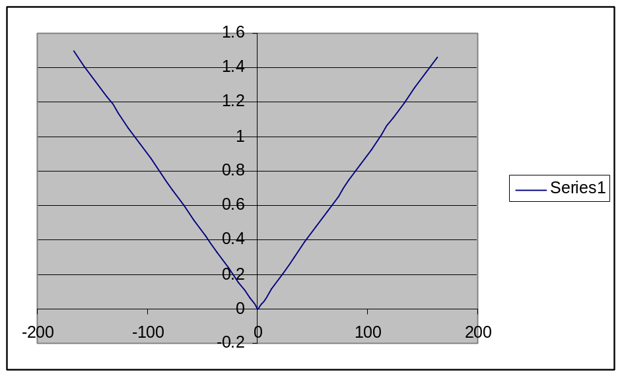

5: New Proposal about the DC motor driving

5.1: Existing DC motor driving analyze

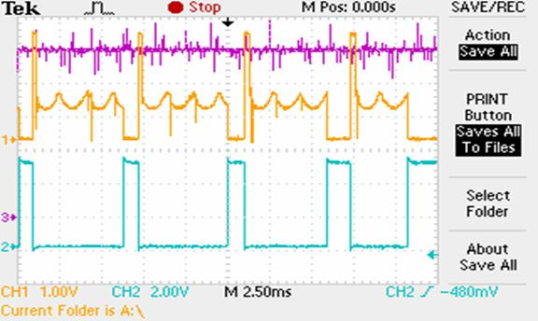

T1 T2 T3

T1: Sample motor FB signal, and output signal high. (PWM_ON)
T2: Output signal low.(PWM_SAMPLE)
T3: Calculate next PWM wave on time.(PWM_SAMPLE_OFF).

From my opinion, I think this solution will have some problems is:
- FB signal noise.
- PWM wave is generate by software, is complex, it is difficult to change the PWM period and can’t generate high frequency PWM wave.
- There are too many things to handle in PWM ISR; it will affect the PWM wave precision.

5.2: The new architecture proposal:

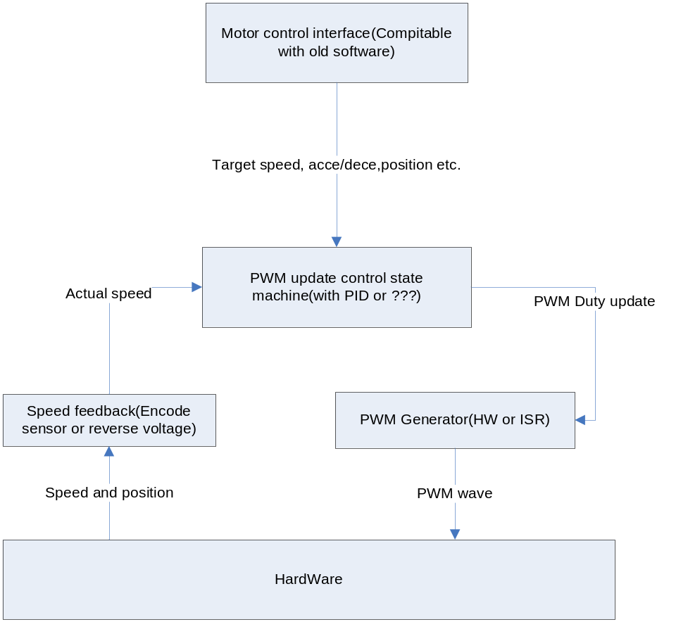

5.2.1: Speed feedback module:
Use a special task to get the motor speed. If the motor has no encoded sensor, disable all of the Motor driving FET and then read the motor BEMF to get motor speed periodically. If the motor has taco, then use taco to get the position and speed value. Don’t use BEMF to get the speed value again.

5.2.2: PWM Generator:
It is a very simply module, if hardware can generate the PWM, call hardware PWM generator directly. Otherwise use a PWM interrupt and a simple ISR to drive GPIO to simulate a PWM. This module get the PWM duty value from PWM update control state module to update PWM duty, don’t handle anything another. So the high frequency PWM wave is possible. And easy to generate dual or single PWM signal.
In old hardware design, because there are many motors need be driven and hardware limits, software generator has to be used, in order to high accuracy PWM, distribute the PWM interrupt to ARM FIQ, and access the hardware IO port directly.
A improvement solution is to use a multiplex to extend the hardware PWM pin, but the hardware has to be modified.

5.2.3: PWM update control state machine:
It is a complicate task, it will receive the required motor information and actual speed value from speed feedback module, then use PID algorithm to update PWM duty, at same time, it will handle motor acceleration, deceleration, motor brake etc.

5.2.4: BEMF filter
According to the result of the experiment, the BEMF signal noise is low, and some filter has to be added.
Sample BEMF signal per

5.2.5: PI control algorithm with sensors motor
If motor has senor to count the motor running distance. New algorithms will be used.
P = Kp*Verr + Ki*Perr
P: PWM duty time.
Verr: motor speed error( the measured speed – motor target speed)
Perr: Motor reference position – motor measured position.
About the motor speed measure, need use a CCU module, it can capture sensor signal failing or raising edge and load the a timer value in a special register automatically.
So can measure a signal pulse period TA(bellowed diagram)

T_{A}
In capture ISR, can count the pulse number easily, it is motor position, so according to the motor target speed and time, can get the reference position. In a high priority task, update the PWM duty every 5ms according to this algorithm.

5.2.6: Acceleration and deceleration control algorithm with sensors motor
In order to decrease the motor startup current and enhance the motor point accuracy, the acceleration and deceleration must be added. So a full of motor running process will like flow diagram.
Firstly the motor start run in acceleration state, when measured speed is larger then target speed, it will enter in steady state, and if position is larger than keen position,
It will enter deceleration state. Keen position calculation is bellowed:
KeenPos = Move distance –Target Speed* Target Speed / 2a
Move distance: Motor run distance( xxx clock)
Target Speed: motor setting speed.
a: Motor deceleration speed, current system, decrease setting speed 1 every 5ms.

start
accel
Steady_state
decel
stop
speed
time
Idle
Idle
Measured speed>=target speed
InputPosition>=KeenPosition
InputVelocity<=0

5.2.4: Implement order:
1: Implement the simple PWM generator.
2: Speed feedback module implement and test.
3: PWM update control state machine implement.
4: System test and parameter fine tune and performance evaluation.

5.2.5: Question
- PWM frequency value.
- BEMF signal filter.
- The current hardware MOS-FET frequency limited.
- PWM update control algorithm selection and parameter fine tune.
- New architecture SW performance evolution and test.

